THERAPEUTIC HORSES OF SARATOGA/ ECS Phycological Service
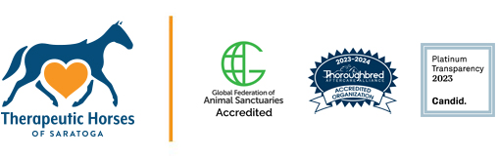
The Freedom Rein Project at Therapeutic Horses of Saratoga offers a unique Military Equine Therapy program for Veterans and service members. Using evidenced-based protocols, participants engage in equine-assisted psychotherapy in a therapeutic environment surrounded by horses. This immersive approach allows individuals to address challenges and work towards goals with the support of these gentle guides.

Health insurance does not cover the full cost of equine therapy which has been a barrier for many service members in accessing this care to address challenges related to trauma experiences and difficulty with reintegration after service. However, the Freedom Rein Project has received the VA Adaptive Sports Grant, enabling them to offer this program free of charge to Veterans and service members. This initiative underscores their commitment to supporting the military community and providing accessible resources to aid in their well-being. For those interested in learning more or getting started, they can reach out to our clinical partners at ECS Psychological Services via email : intake@ecsps.com or at 518-580-0520 ext. 1.
Dana Panetta LMHC, CASAC
Director of Military Programs, ECS Psychological Services
Assistant Director, Therapeutic Horses of Saratoga
683 RT 29 | Saratoga Springs, NY 12866
P: 518-580-0520 x122 | F: 518-580-9975
www.ecsps.com | www.thsaratoga.org

